

Smoke Detector and Fire Alarm: WIFI-connected, Directional Path Evacuation

Senior Design 1

Initial Project Identification Document

February 2017

Group A

**Carlos Castro**, Computer Engineering

**Courtnie Coleman**, Electrical Engineering

**Lucas Plager**, Computer Engineering

**Patrick Schexnayder**, Electrical Engineering

Customers, Sponsors and Significant Contributors:

**Motivation**

In today’s day and age, technology advancements are occurring at a rapid pace. There are new inventions being created every minute improving people’s lives and making the world a better and safer place. Our group saw that while technology is advancing and becoming a bigger part of our everyday lives, one piece of technology that has not seen a major improvement in decades is the smoke detector and fire alarm. This device is a standard in everyone’s homes, offices, hotels and all other major buildings that we spend time in every single day but has been neglected as far as engineering advancement and innovation is concerned. The smoke detector and fire alarm that you have inside your house is essentially the same one your parents had inside theirs. We think we can do better. When looking at the average use case of a smoke detector, it was discovered that while they are useful, these devices do not provide the user with an abundance of information. Frequently someone would hear the alarm go off and just frantically run to wherever they believe to be the nearest and safest exit without much of a plan. This scenario has the potential for disaster when you consider that there could be multiple people inside the building who do not know their way around and could be endangering themselves. Individuals could be wasting valuable time or be heading in a direction that is dangerous. We believe that a smoke alarm with improved functionality can help to eliminate this scenario and make everyone’s lives easier, and most importantly, safer. This can be achieved by creating a more connected fire alarm system, when the location of a fire is a factor in directing evacuation of a building, communication between the detection system and alarm system can provide crucial, life-saving information.

**Goals, Objectives, and Function**

The goals for the smart smoke detector and fire alarm are to make an affordable, customizable, connected system of smoke alarms that alert employees and residents of the safest and fastest exit of the building in the case of a fire emergency. We would like this system to not be that much more expensive than existing options to convince the market to adopt our system. In the event of an emergency, these smoke alarms would sound off in an order that would lead people to the closest and safest exit. Users would just have to follow the sound that is projected from these alarms until they reach the exit to the building. These smoke alarms would be dynamic in the sense that they adapt to where the fire is located. This means that if a smoke alarm that is in the middle of a hallway goes off, people on the left of that area would be directed to the exit that is closest on their side of the fire while people on the right of that area would be directed to the exit that is closest on the other side of the fire and nobody is directed though the dangerous area. The system would also be able to handle hallway intersections and other confusing areas. This allows for residents to know where the fire is and what areas to avoid. For people that have hearing issues, these alarms will also have a visual display that will point people in the direction they should go to exit the building using light-up arrows. This also allows for better handling of confusing areas where sound alone could be confusing. This should be achieved by mapping the building layout using a custom-made application on an embedded system, creating spatial awareness for each of the fire alarms, and using an algorithm to signal each alarm which what the best exit direction is relative to its position.

**Engineering Requirements/Specifications**

The fire alarm that will be designed will give a clearer indication as to where to go during a fire. For this system to work each alarm will be connected to each other and will be able to send and receive signals. This system will be mapped to the floor plan of the building, so that when a fire breaks out the alarm system will recognize where the fire is coming from and send out a signal to each alarm to light the LEDs in the direction people should go to get away from the fire.

1. Smoke sensors

Smoke sensor will be used to detect smoke within the building, there are different types of smoke sensors to detect fast flaming fires and slow smoldering fires. Upon more research we will be decided which would be best for us to use within our fire alarm.

1. Transmitter and receiver

For this fire alarm system, we want to make sure to direct the people away from the fire and to the closest exit. For this to work we will need each alarm device to be connected to each other. So each separate alarm will have a transmitter and a receiver so that way each alarm would be able to communicate to each other, and send the correct signal.

1. Software

For the fire alarm system to be successful we will be using a script language to program the devices to recognize the layout of the building, and to be able to set off the sequence as to where to go when one of the smoke sensors go off.

1. Battery

For the fire alarm system, it will be using a 9v battery with 1200 mAh current, due to some research on current fire alarm systems and the profession grade batteries they use.

1. Lights

To help with the indication of a fire, and to help direct people in the right direction away from the fire there will be two LEDS in the shape of arrows on the fire alarm. Depending on the signal that is sent out, one of the arrows would illuminate in the direction to go. This will help give a clearer indication as to where the fire maybe and where to go.

**House of Quality**



**Block Diagram (Hardware/Software)**

**Budget**

**Financing Plan**

While everyone on the team has agreed to share any financial burden created by the project equally, we will seek sponsorships and other means to finance this project. Upon selecting a project, and receiving approval we will submit proposals to companies interested in investing in fire alarms and those looking to showcase their semiconductor and component products. A tentative list includes: Texas Instruments, Taiwan Semiconductor Manufacturing, Honeywell Fire Systems, Siemens (Building Technology Division), and UCF. If no sponsorship or financial help is achieved, the team is responsible for any costs incurred.

**Project Timeline**

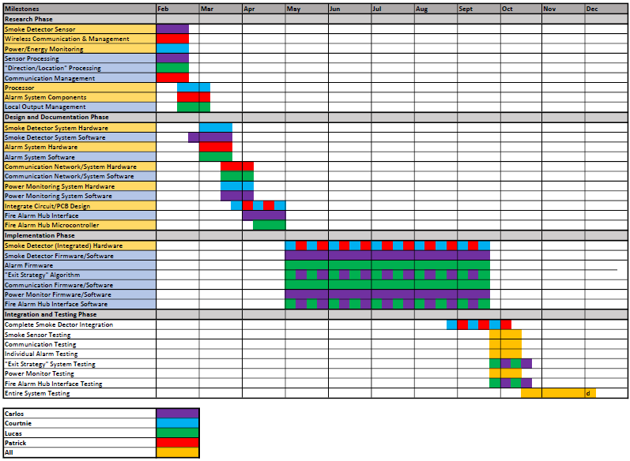

**Decision Matrix**